# DATA VISUALIZATION

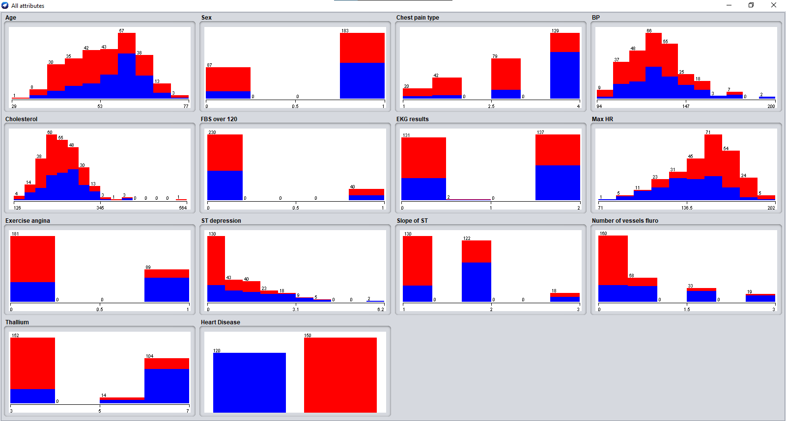

# C4.5 IMPLEMENTATION IN WEKA USING JAVA LIBRARY J48

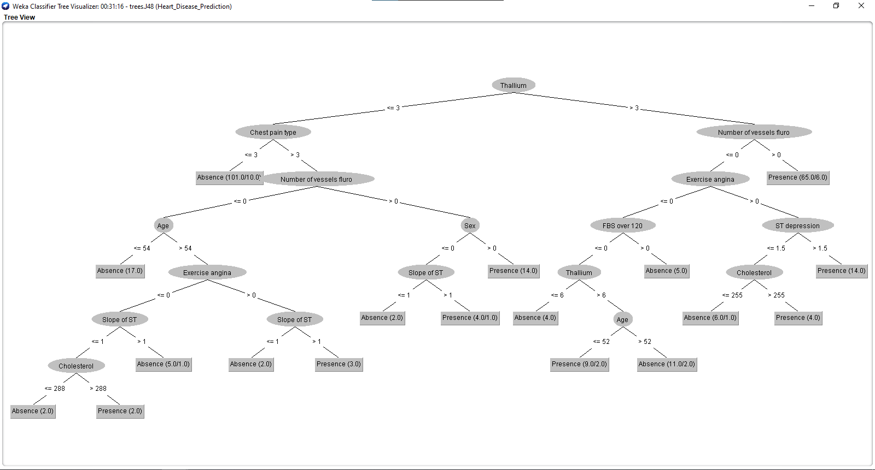

# PLOT MATRIX

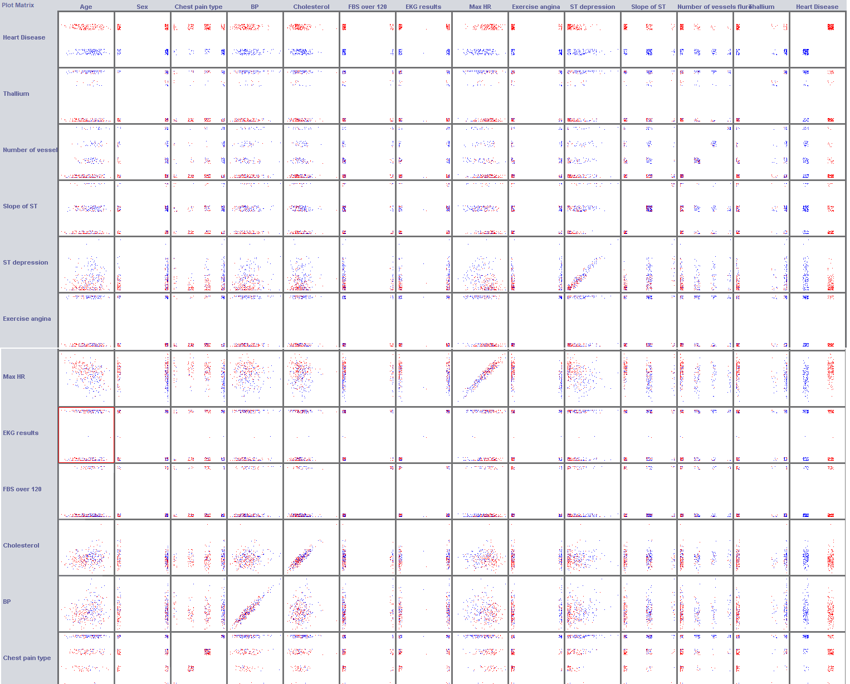

# AGE VS HEART DISEASE

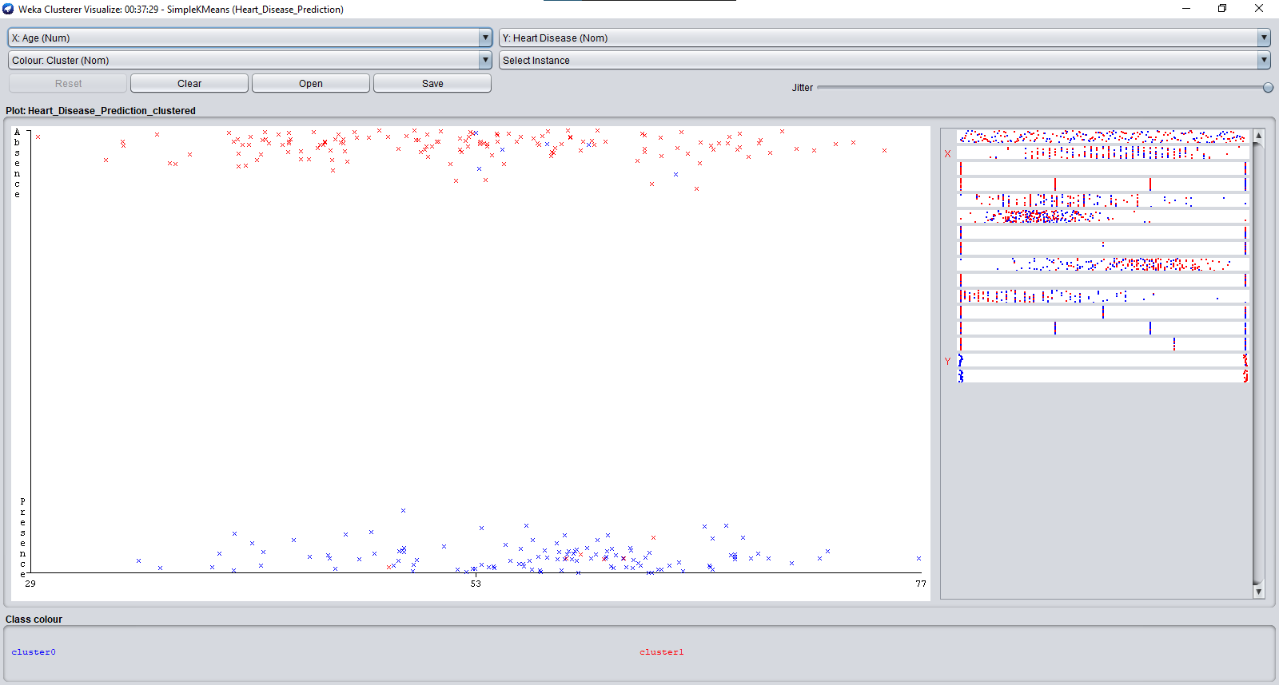

# SEX VS HEART DISEASE

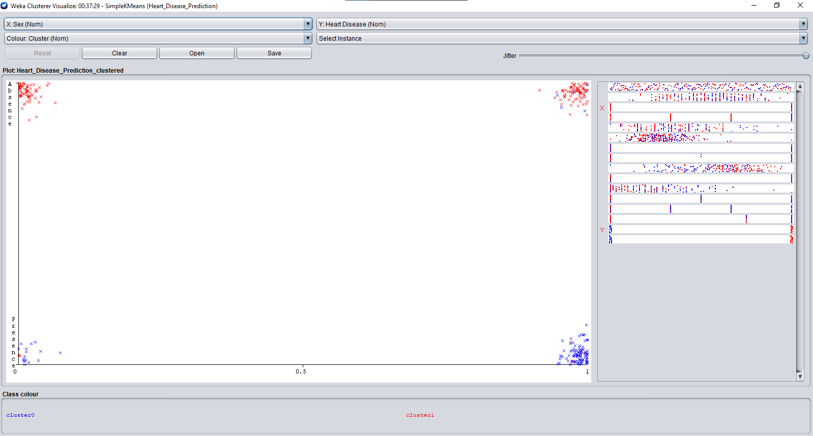

# CHEST PAINT TYPE VS HEART DISEASE

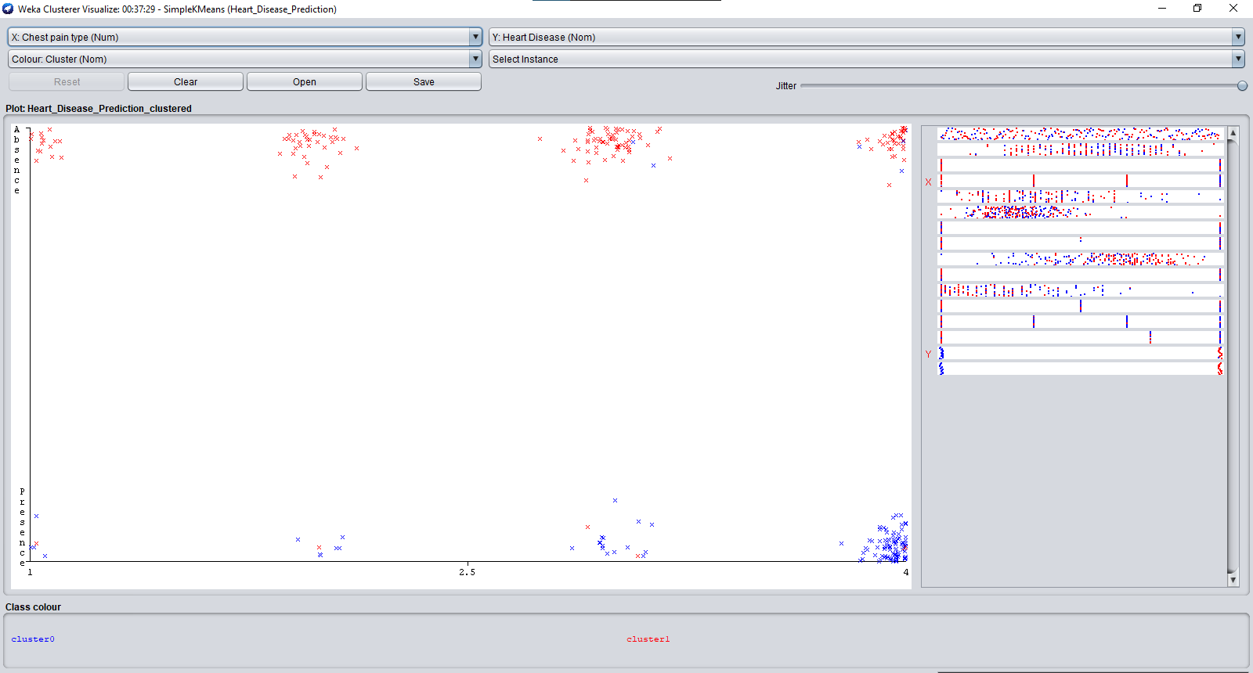

# BP VS HEART DISEASE

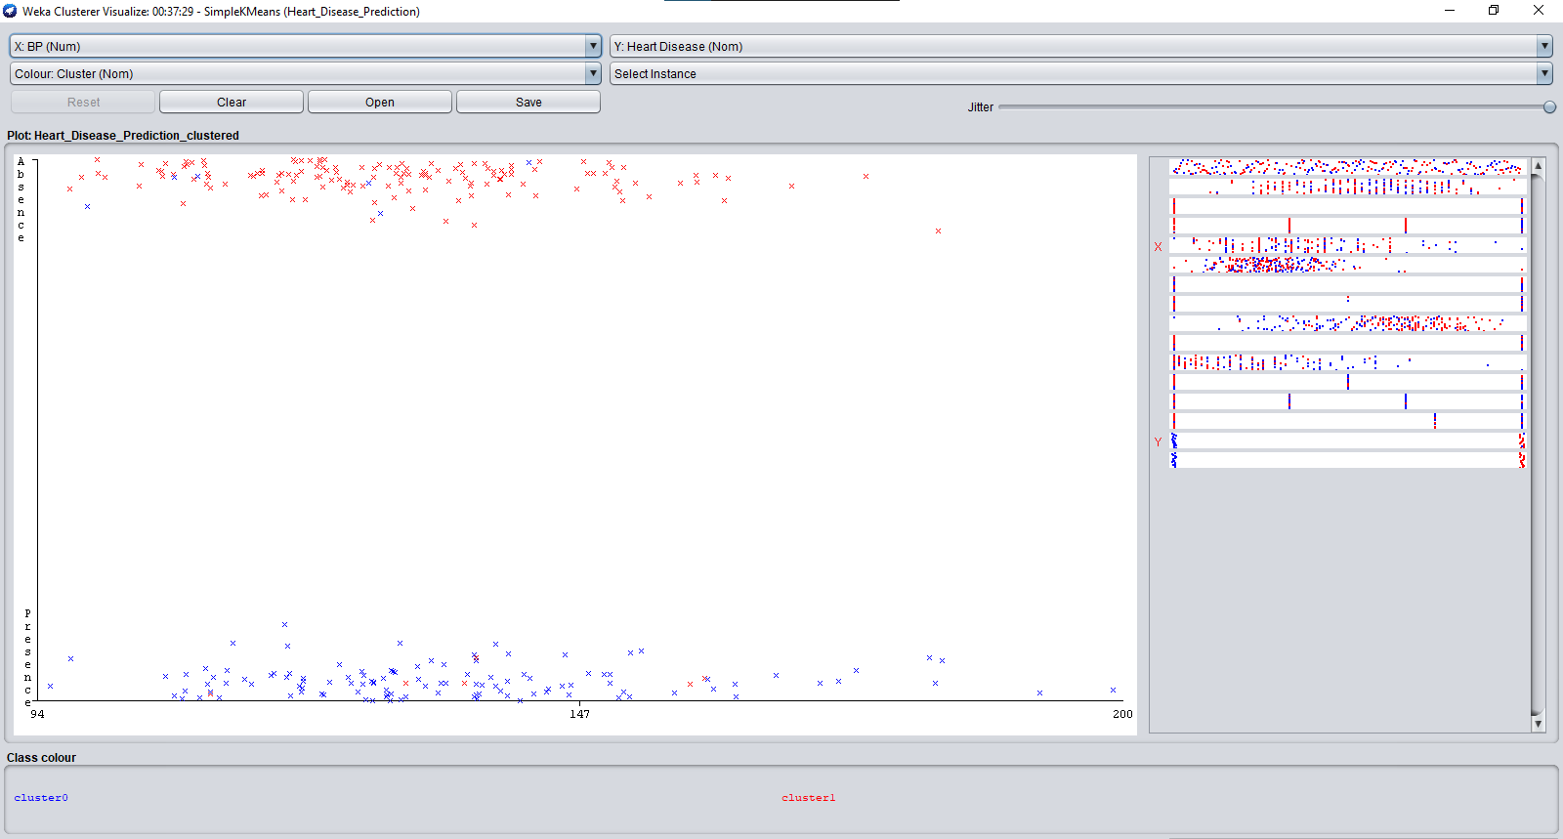

# CHOLESTROL VS HEART DISEASE

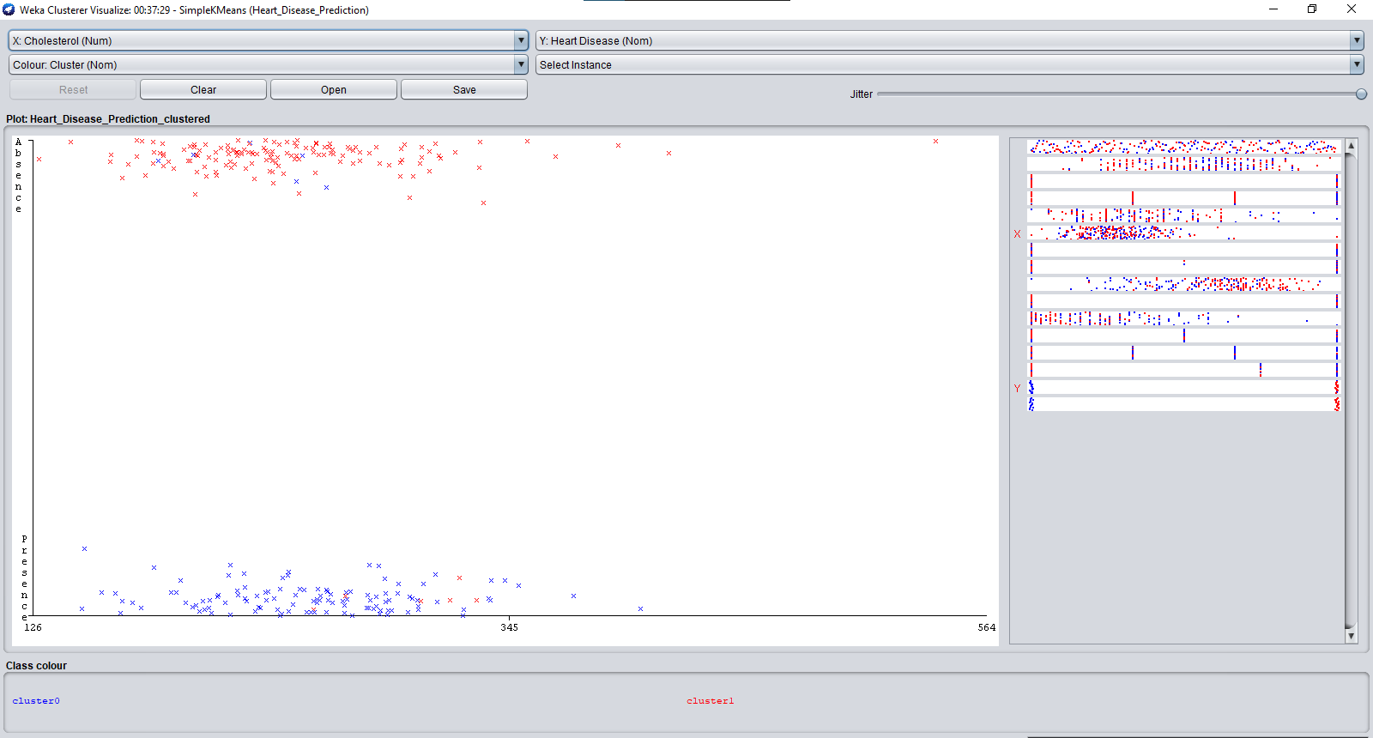

# FBS OVER 120 VS HEART DISEASE

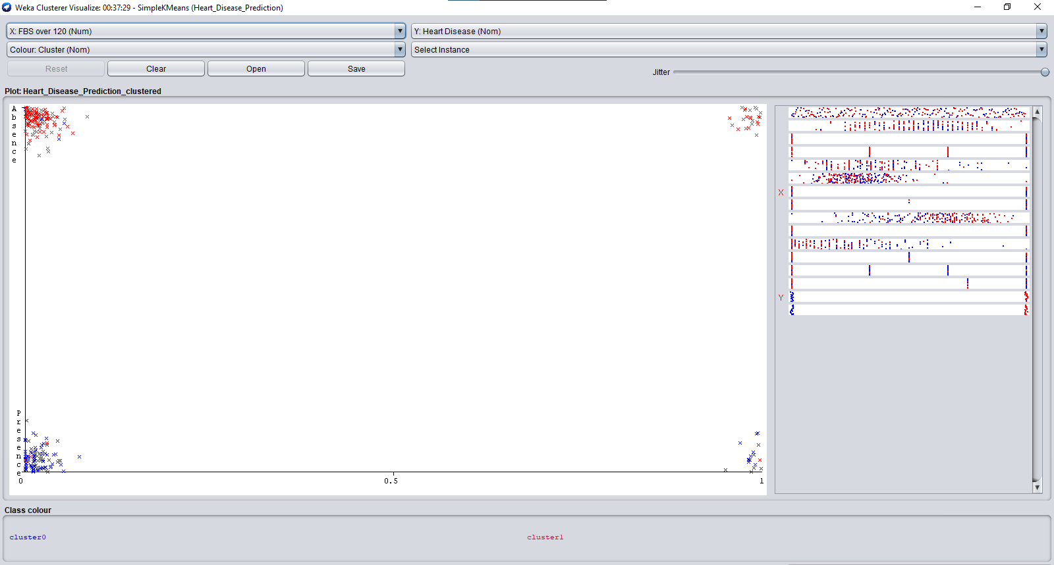

# EKG RESULTS VS HEART DISEASE

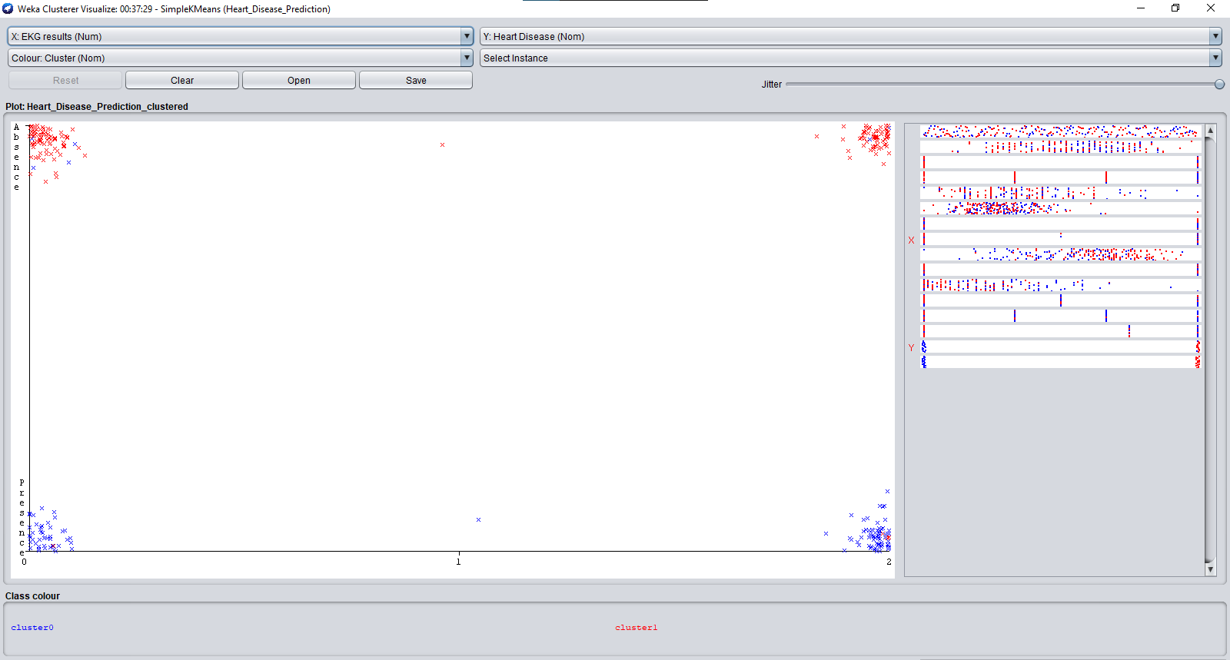

# MAX HR VS HEART DISEASE

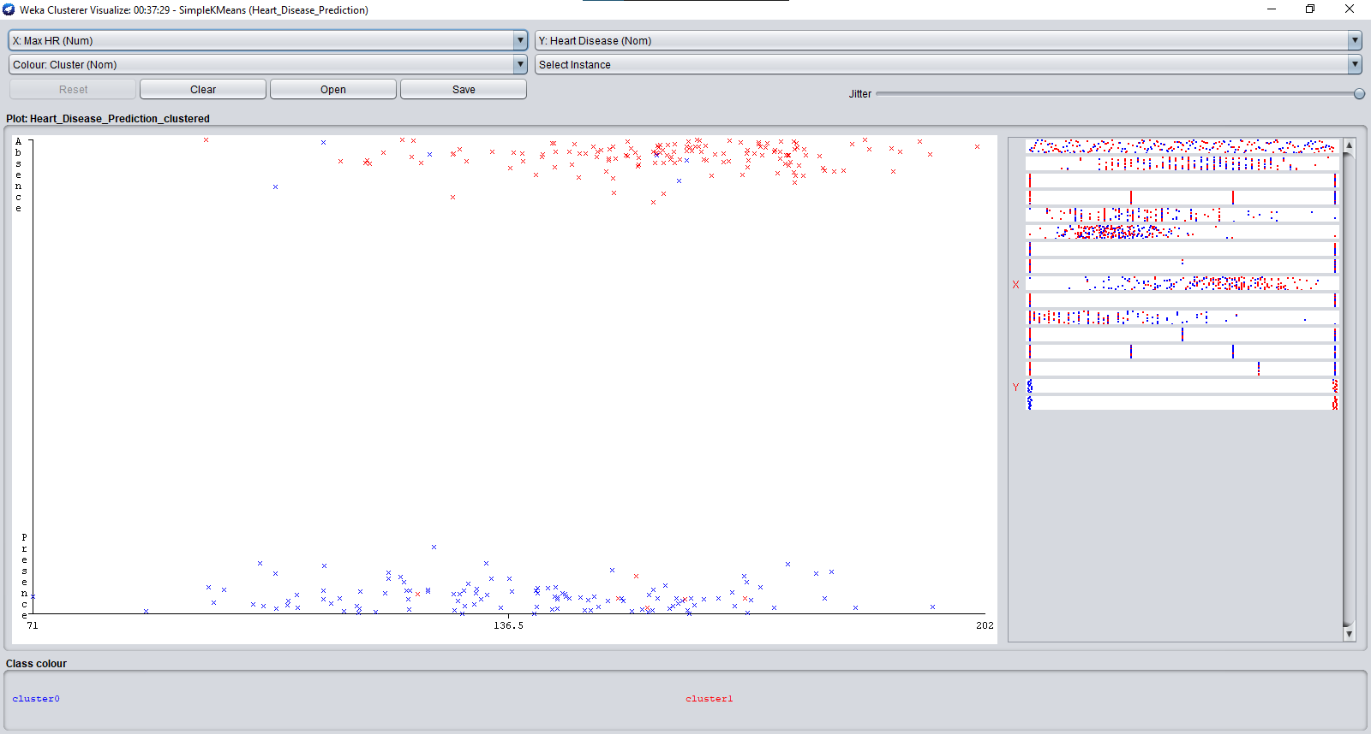

# EXERCISE ANGINA VS HEART DISEASE

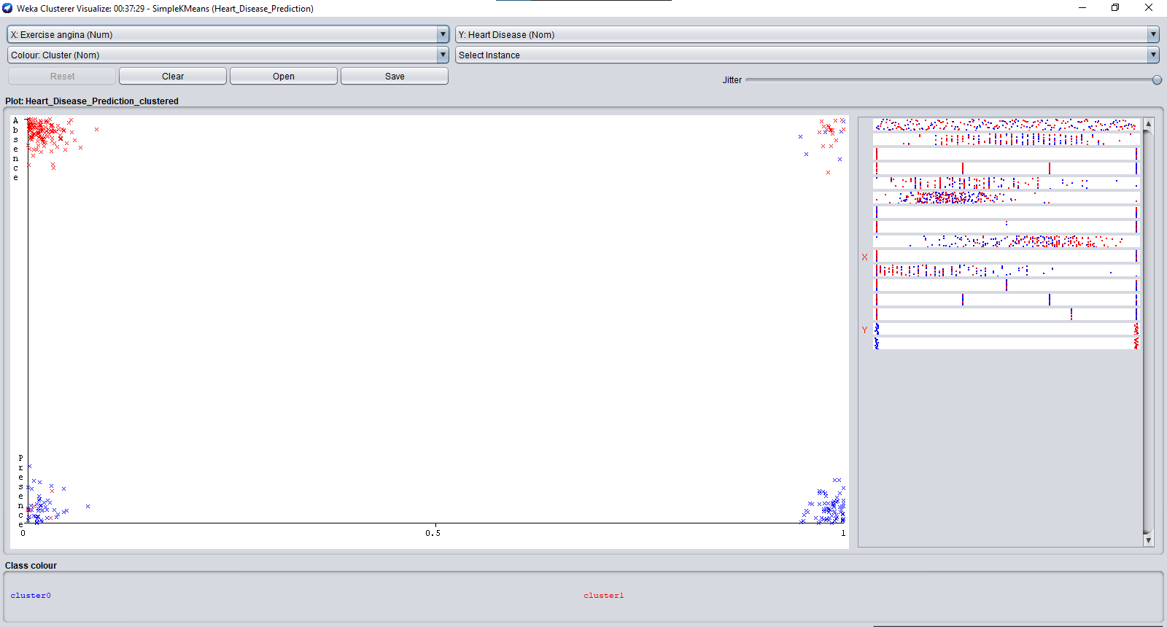

# ST DEPRESSION VS HEART DISEASE

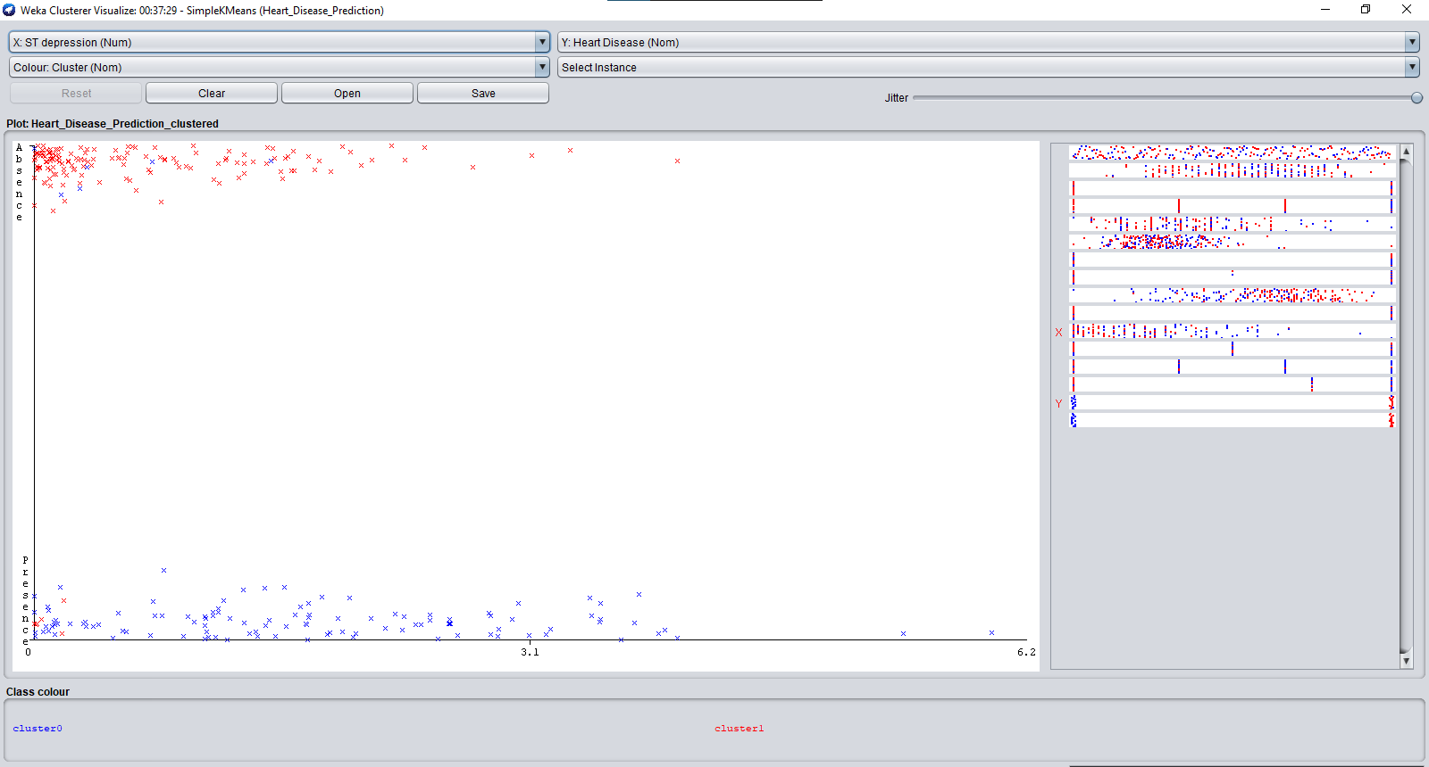

# SLOPE OF ST VS HEART DISEASE

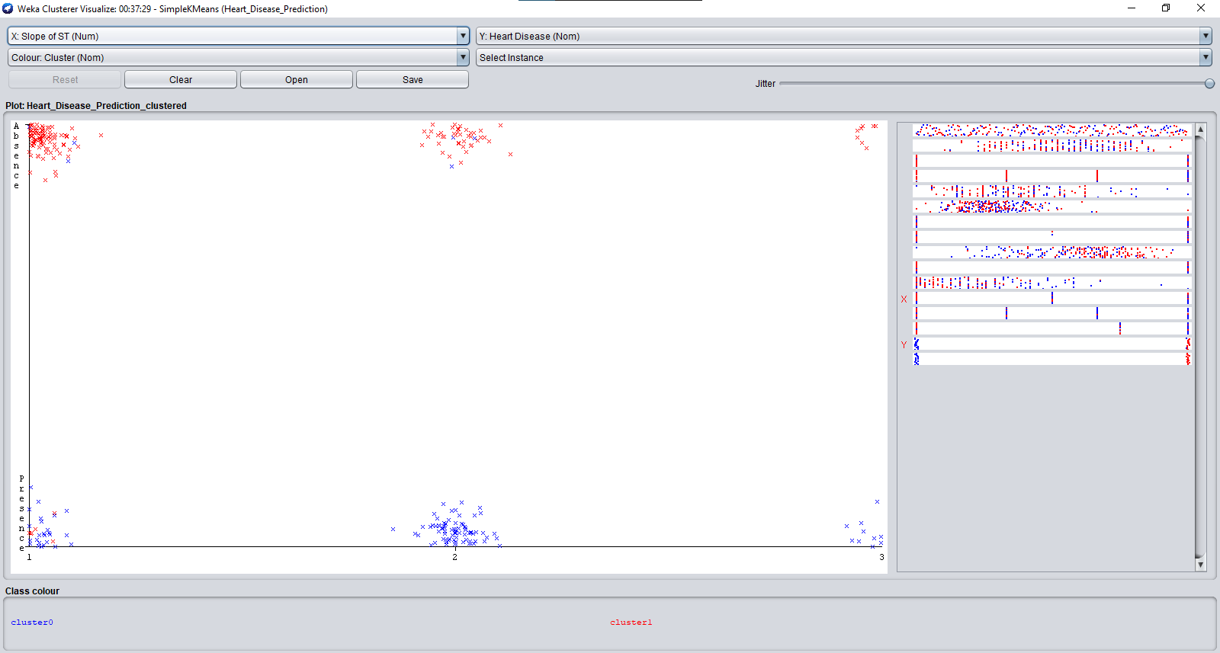

# NO. OF VESSELS FLURO VS HEART DISEASE

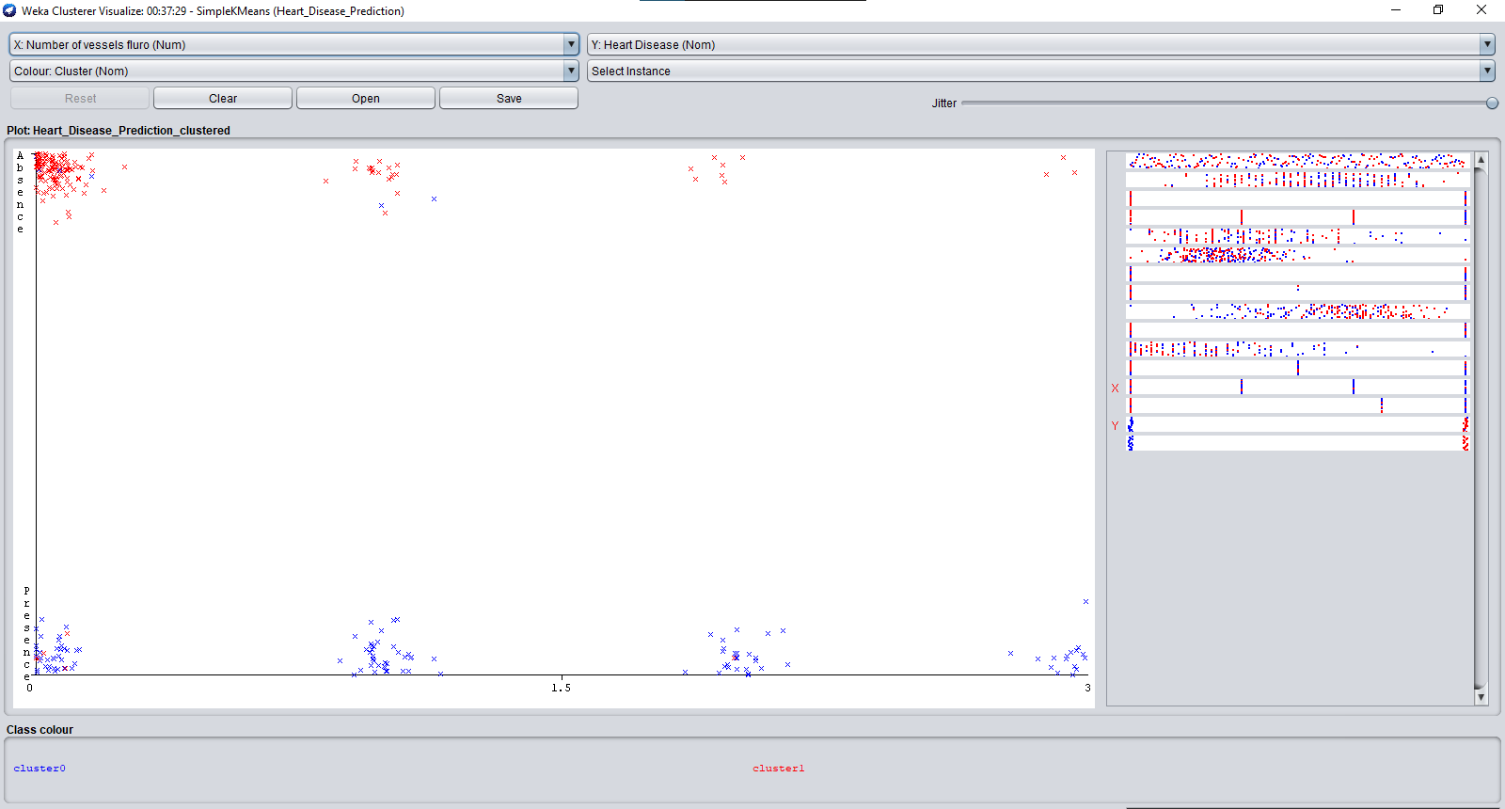

# THALLIUM VS HEART DISEASE

